Simonds High School
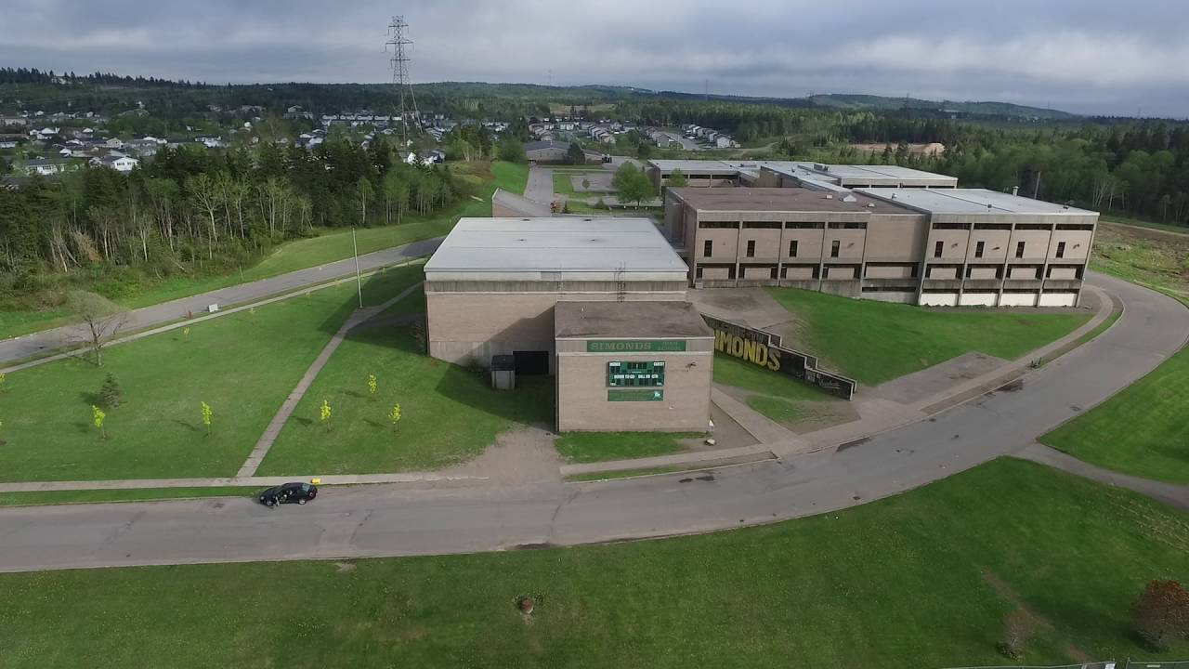

School Improvement Plan

*Vision Statement
Our vision is to provide a balanced, quality education in a positive learning environment designed to meet the needs of all students and enhance their development in becoming effective citizens.

*Mission Statement
Simonds High School is committed to creating a community of empowered learners in an environment of mutual respect and trust. Students will be inspired and challenged to acquire the knowledge, skills, attitudes, and values to successfully contribute to our evolving society.

Priority #1 Strengthen Tier 1 interventions by fostering a positive and inclusive school culture where every student is actively engaged and supported. Staff will ensure that all learning environments are welcoming, orderly, healthy, and safe, while consistently maintaining high academic and behavioral expectations for every student.

- Student Engagement:
By the end of the school year, students will demonstrate increased engagement, as evidenced by improved scores in belonging, safety, and participation on the Tell Them From Me Survey, active involvement in Principal Advisory and other engagement activities, and measurable growth in academic performance, with at least a 10% increase in overall achievement indicators compared to the start of the year.

- Behavioral Outcomes:
By the end of the school year, Tier 2 and Tier 3 behavioral referrals will decrease by at least 10% through consistent implementation of Tier 1 behavior supports and proactive classroom management strategies, as measured by ESS referral data.

Strategies to Achieve the Goal:

Schoolwide Practices

- Increase family communication, with a focus on positive engagement (Positive Buzz) to support consistent expectations between home and school.

- Implement and reinforce a Positive Behavioral Interventions and Supports (PBIS) framework across all classrooms/school.

- Establish common expectations for behavior and academic effort that are explicitly taught, modeled, and reinforced schoolwide.

- Conduct regular Tier 1 data reviews (academic and behavioral) to monitor trends and identify areas for staff support (through ESS).

- Recognize and celebrate positive student behavior and academic effort through a consistent schoolwide recognition system.

Classroom Practices

- Ensure that each classroom environment promotes inclusion and belonging (e.g., diverse representation in materials, student voice and choice reflected in classroom norms).

- Implement social-emotional learning (SEL) lessons to build student self-regulation, empathy, and problem-solving skills.

- Provide professional development (through pilot days) focused on evidence-based Tier 1 instructional strategies, including differentiation, active learning, and formative assessment.

Monitoring & Support

- Administrators and SPRs will conduct classroom walkthroughs to observe Tier 1 implementation and provide feedback and coaching.

- Use department teams or PLCs to review student performance and behavior data monthly to refine Tier 1 supports.

- Provide targeted support and professional learning for staff in areas identified through survey data.

Priority #2 The school community will strengthen attendance through a PBIS framework that emphasizes proactive support, positive reinforcement, and equitable access to interventions. Staff will create a culture where attendance is valued, recognized, and supported, using data-driven RTI processes to ensure that all students feel safe, connected, and motivated to attend school regularly.

- Connectedness, Engagement & Relatedness Goal:
By the end of the school year, student engagement and sense of belonging will increase by at least 10%, as measured by school climate survey indicators related to “feeling connected to school” and “staff support.”

- Attendance Improvement Goal:
By the end of the school year, the overall student attendance rate will increase by at least 10% through consistent implementation of Tier 1 PBIS strategies and attendance recognition systems, as measured by official attendance records.

- Chronic Absenteeism Reduction Goal:
Reduce the percentage of students identified as chronically absent (missing 10% or more school days) by 10% compared to the previous school year, through early identification and tiered interventions.

Strategies to Achieve the Goal:

Tier 1 (Universal / PBIS Foundations)

- Ensure classroom environments are welcoming, inclusive, and engaging by using trauma-informed and culturally responsive practices, alongside restorative, solution-focused discussions that promote belonging and reduce student avoidance.

- Implement a schoolwide attendance recognition system that acknowledges positive attendance patterns (e.g., “On-Time Heroes,” class attendance challenges, Student reward breakfast, Positive Buzz, etc.).

- Embed attendance as a PBIS core value, connecting it to existing schoolwide expectations (e.g., Bee Respectful, Bee Responsible, Bee Ready to Learn).

- Teach, model, and celebrate attendance expectations during class meetings, PBIS lessons, assemblies and Newsletters.

- Incorporate attendance data into PBIS team meetings and use it to identify universal trends and plan supports.

- Provide positive communication (Positive Buzz) with families highlighting improvements in attendance and celebrating consistency.

Tier 2 (Targeted Supports)

- Identify students showing early signs of attendance decline through data monitoring tools (e.g., 5 absences).

- Use Check-In/Check-Out (CICO) or mentoring systems to strengthen adult-student connections.

- Develop small-group supports focusing on motivation, organization, and problem-solving related to attendance barriers.

- Partner with families using solution-focused, strength-based conversations to identify and reduce attendance barriers.

Tier 3 (Intensive / Individualized Supports)

- Create individual attendance success plans that include student voice, family collaboration, and wraparound services.

- Coordinate with counselors, social workers, and community agencies to address chronic absenteeism and underlying challenges.

- Provide increased positive reinforcement for incremental improvements in attendance (e.g., weekly goals and recognition).

- Conduct PBIS Tier 3 team reviews monthly to evaluate student progress and adjust supports.

